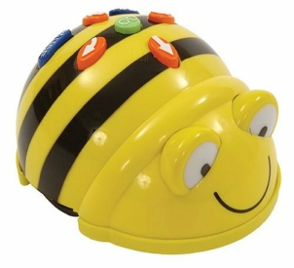  2D Shapes | 2D Shapes
2D Shapes | 2D Shapes

Bee-bot 2D Shapes Activity Card  Program the Bee-bot to move from the large blue square to the large green square | Bee-bot 2D Shapes Activity Card  Program the Bee-bot to move from the small blue square to the yellow triangle
Bee-bot 2D Shapes Activity Card  Program the Bee-bot to move from the large red circle to the green rectangle | Bee-bot 2D Shapes Activity Card  Program the Bee-bot to move from the red triangle to the yellow circle

Bee-bot 2D Shapes Activity Card  Program the Bee-bot to move from the Yellow Rectangle to the blue triangle | Bee-bot 2D Shapes Activity Card  Program the Bee-bot to move from the large blue circle to the yellow square
Bee-bot 2D Shapes Activity Card  Program the Bee-bot to move from the red triangle to the small green rectangle | Bee-bot 2D Shapes Activity Card  Program the Bee-bot to move from the yellow circle to the large green square

Bee-bot 2D Shapes Activity Card  Program the Bee-bot to move from the green triangle to the red rectangle | Bee-bot 2D Shapes Activity Card  Program the Bee-bot to move from the large red circle to the small yellow circle
Bee-bot 2D Shapes Activity Card  Program the Bee-bot to move from the to the green rectangle | Bee-bot 2D Shapes Activity Card  Program the Bee-bot to move from the red triangle to the yellow circle

