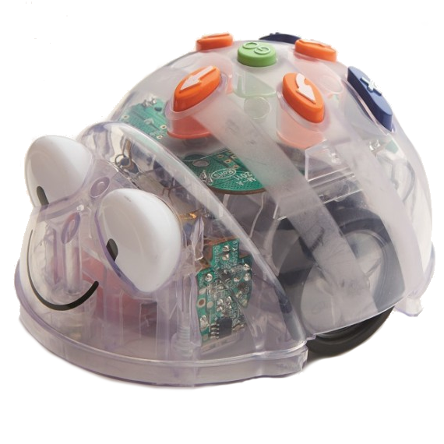  Australia | Australia
Australia | Australia

Australia Activity Card  Program the Blue-bot to move from Cradle Mountain Tasmania to Kakadu National Park Northern Territory  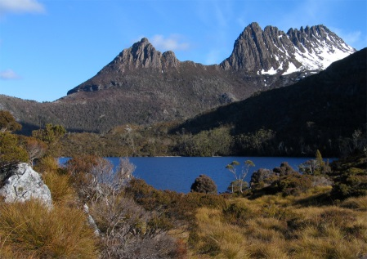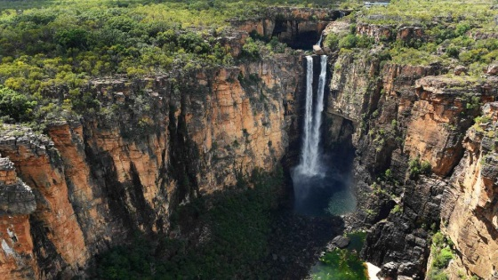 | Australia Activity Card  Program the Blue-bot to move from Loch Ard Gorge, The Great Ocean Road Victoria to Horizontal Falls Western Australia  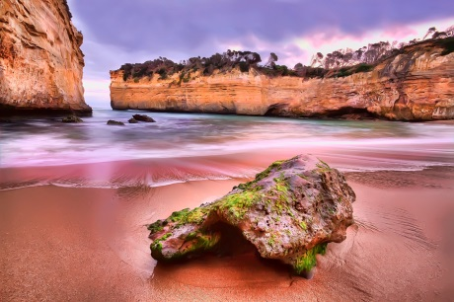  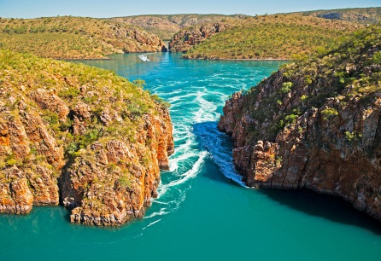
Australia Activity Card  Program the Blue-bot to move from the Opera House NSW to Heart Reef, Great Barrier Reef Queensland  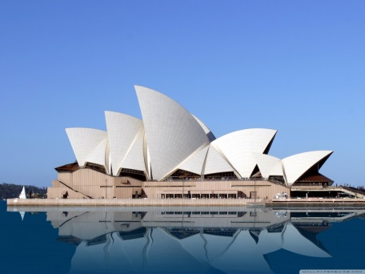  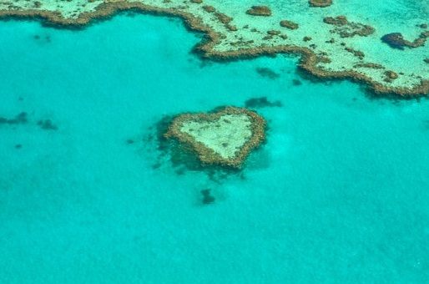 | Australia Activity Card  Program the Blue-bot to move from the Twelve Apostles, The Great Ocean Road Victoria to Lake Eyre South Australia  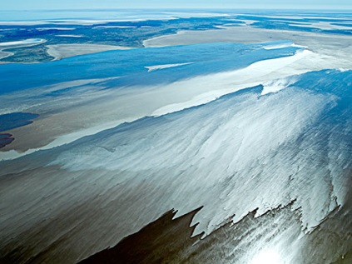  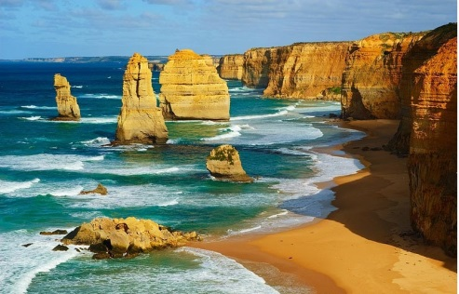

Australia | Australia
Australia | Australia

Australia Activity Card  Program the Blue-bot to move from The War Memorial ACT to Wave Rock Western Australia  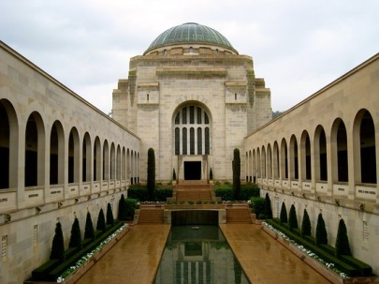  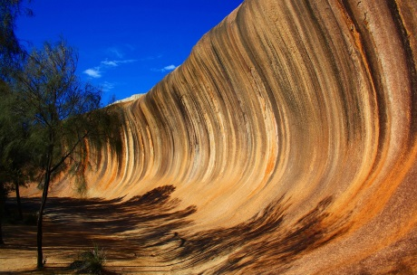 | Australia Activity Card  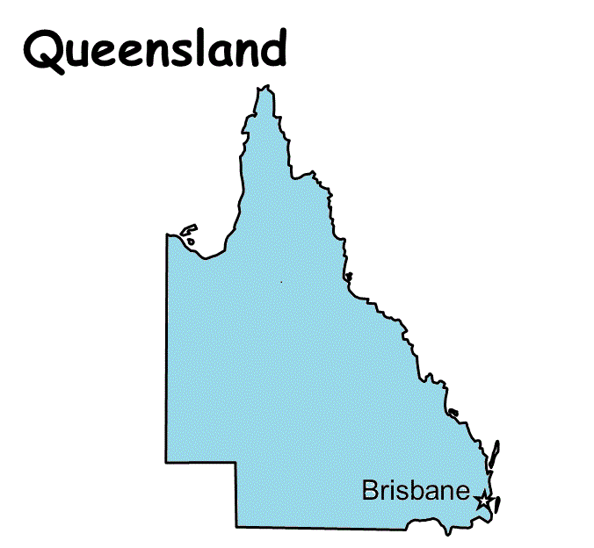  Program the Blue-bot to move from the Australian Capital Territory (ACT) to Queensland  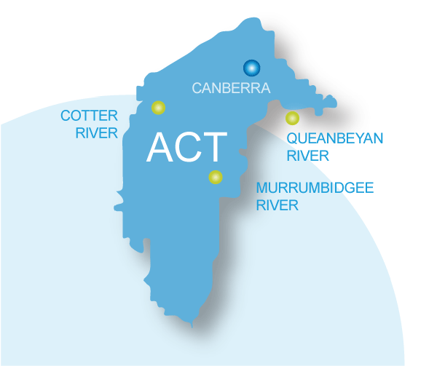
Australia Activity Card  Program the Blue-bot to move from The Three Sisters, Blue Mountains NSW to Uluru Northern Territory  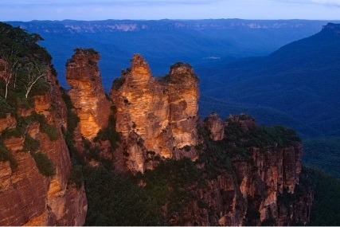  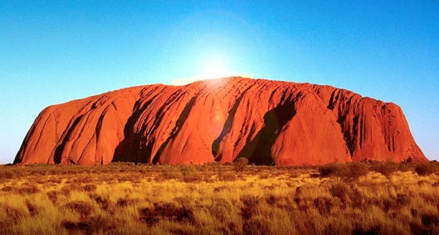 | Australia Activity Card  Program the Blue-bot to move from Port Arthur Tasmania to Remarkable Rocks South Australia  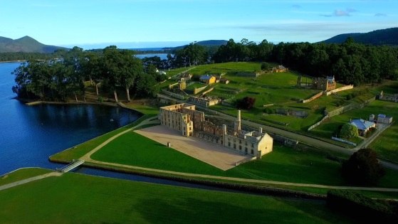  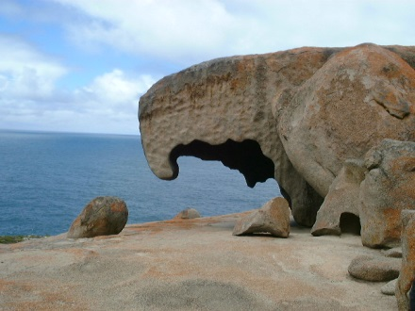

Australia | Australia
Australia | Australia

Australia Activity Card  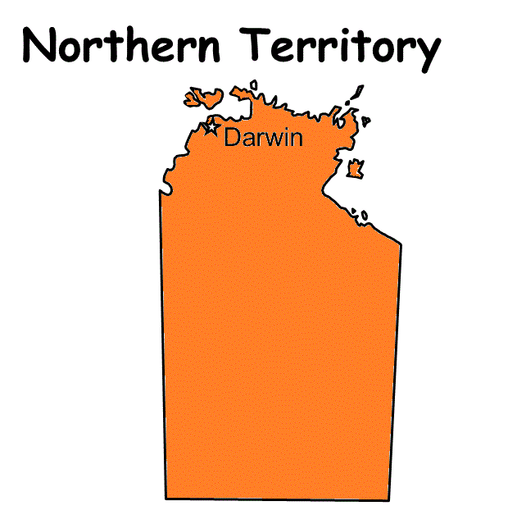  Program the Blue-bot to move from the Northern Territory to South Australia  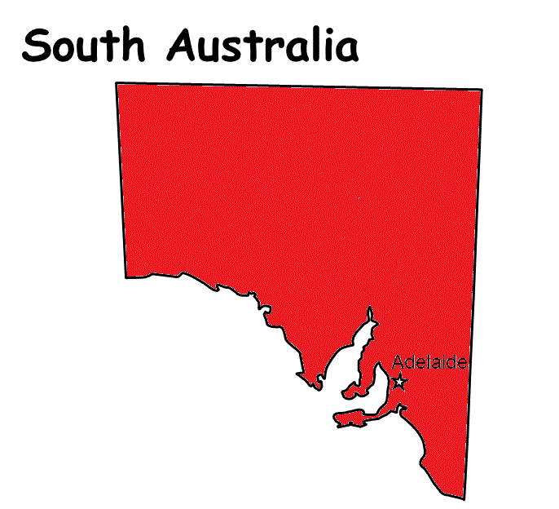 | Australia Activity Card  Program the Blue-bot to move from Victoria to Western Australia  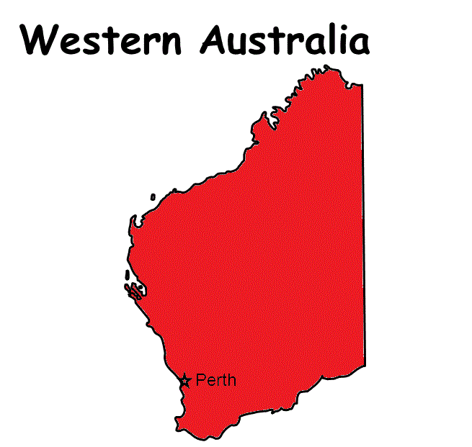  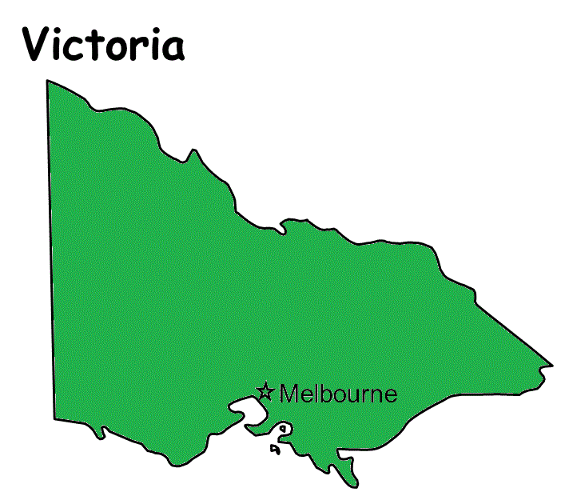
Australia Activity Card  Program the Blue-bot to move from New South Wales to Tasmania  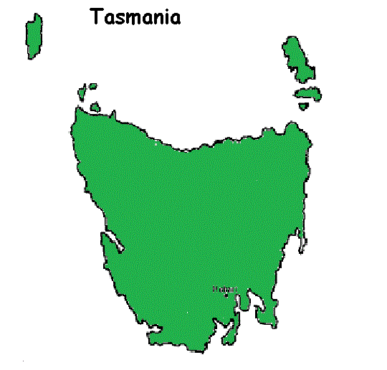  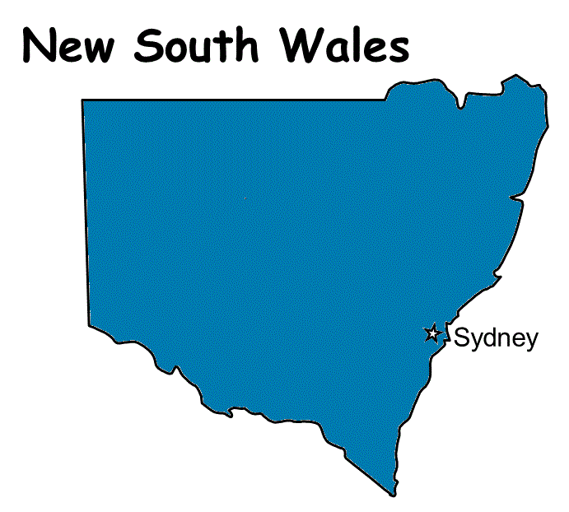 | Australia Activity Card  Program the Blue-bot to move from Fraser Island Queensland to Parliament House ACT  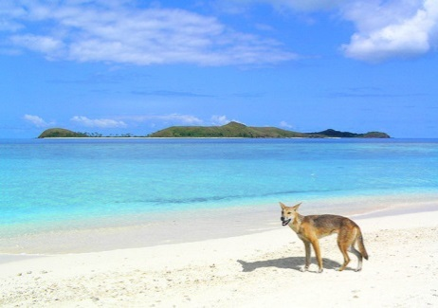

Australia | Australia
Australia | Australia

 | Australia Activity Card  Program the Blue-bot to move from Heart Reef, The Great Barrier Reef Queensland to Lake Eyre South Australia  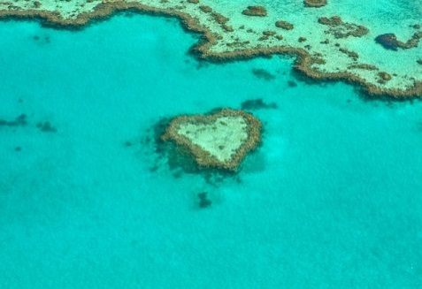  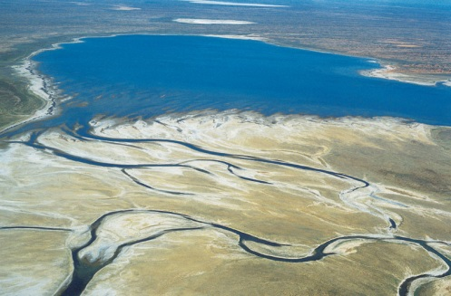 |  | Australia Activity Card  Program the Blue-bot to move from Uluru Northern Territory to The Australian War Memorial ACT  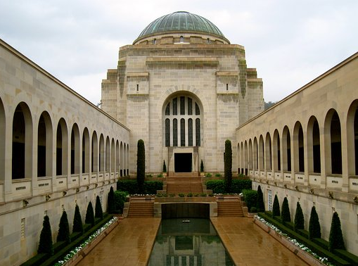  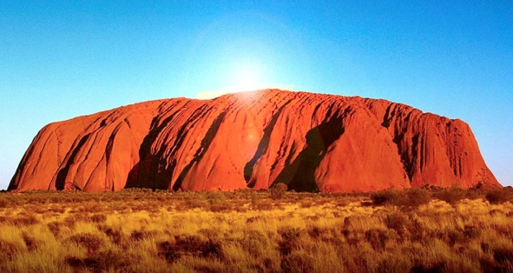
 | Australia Activity Card  Program the Blue-bot to move from Horizontal Falls Western Australia to The Twelve Apostles, Great Ocean Road Victoria  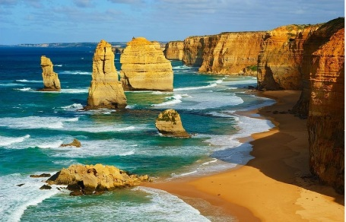  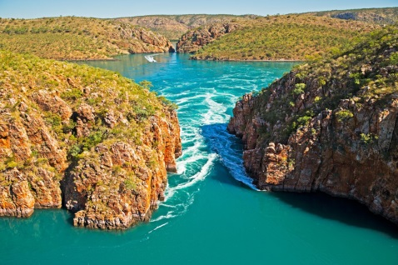 |  | Australia Activity Card  Program the Blue-bot to move from Wave Rock Western Australia to Remarkable Rocks South Australia  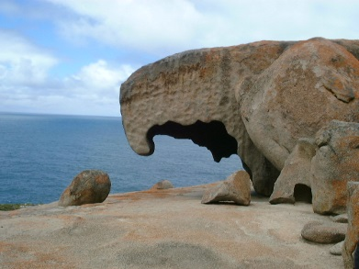  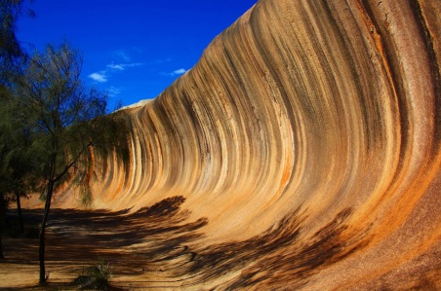
Australia |  | Australia
Australia |  | Australia

 | Australia Activity Card  Program the Blue-bot to move from Cradle Mountain Tasmania to the State of Tasmania |  | Australia Activity Card  Program the Blue-bot to move from the State of Western Australia to Horizontal Falls Western Australia
 | Australia Activity Card  Program the Blue-bot to move from the State of Queensland to Heart Reef, Great Barrier Reef Queensland |  | Australia Activity Card  Program the Blue-bot to move from the Twelve Apostles, The Great Ocean Road Victoria to the State of Victoria
Australia |  | Australia
Australia |  | Australia

Australia Activity Card  Program the Blue-bot to move from Cradle Mountain Tasmania to Kakadu National Park Northern Territory | Australia Activity Card  Program the Blue-bot to move from the Northern Territory to Uluru Northern Territory  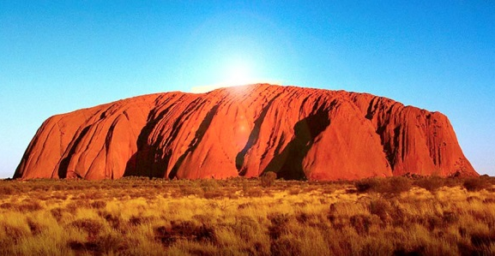
Australia Activity Card  Program the Blue-bot to move from the Sydney Opera House NSW to the State of NSW | Australia Activity Card  Program the Blue-bot to move from the State of South Australia to Lake Eyre South Australia

Australia | Australia
Australia | Australia

Australia Activity Card  Program the Blue-bot to move from | Australia Activity Card  Program the Blue-bot to move from
Australia Activity Card  Program the Blue-bot to move from | Australia Activity Card  Program the Blue-bot to move from

