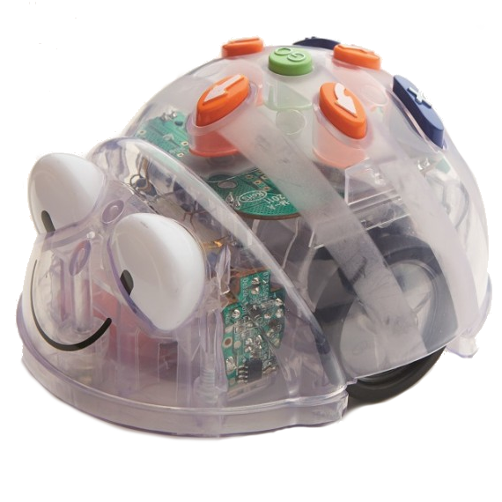  Emotions | Emotions
Emotions | Emotions

 | Emotions Activity Card  Program the Blue-bot to move from confused to curious |  | Emotions Activity Card  Program the Blue-bot to move from worried to proud
 | Emotions Activity Card  Program the Blue-bot to move from nervous to confident |  | Emotions Activity Card  Program the Blue-bot to move from worried to hopeful
Emotions |  | Emotions
Emotions |  | Emotions

Emotions Activity Card  Program the Blue-bot to move from anxious to confident | Emotions Activity Card  Program the Blue-bot to move from shy to love
Emotions Activity Card  Program the Blue-bot to move from ashamed to relieved | Emotions Activity Card  Program the Blue-bot to move from aggressive to hopeful

Emotions | Emotions
Emotions | Emotions

Emotions Activity Card  Program the Blue-bot to move from sad to happy | Emotions Activity Card  Program the Blue-bot to move from exhausted to satisfied
Emotions Activity Card  Program the Blue-bot to move from jealous to thoughtful | Emotions Activity Card  Program the Blue-bot to move from shocked to surprised

Emotions | Emotions
Emotions | Emotions

Emotions Activity Card  Program the Blue-bot to move from frustrated to proud | Emotions Activity Card  Program the Blue-bot to move from nervous to excited
Emotions Activity Card  Program the Blue-bot to move from confused to thoughtful | Emotions Activity Card  Program the Blue-bot to move from angry to happy

