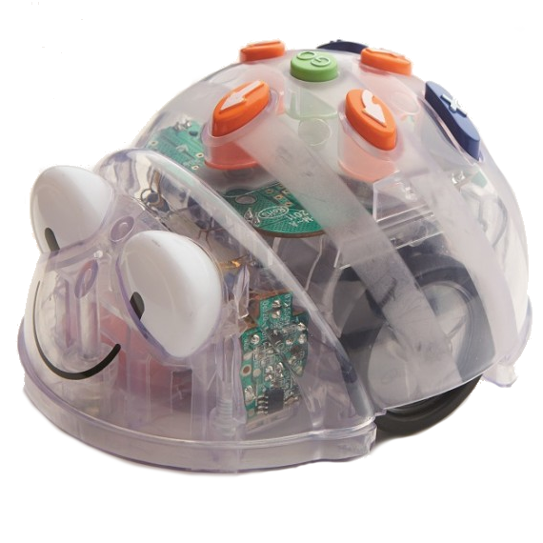  English - Texts | English - Texts
English - Texts | English - Texts

 | English Texts Activity Card  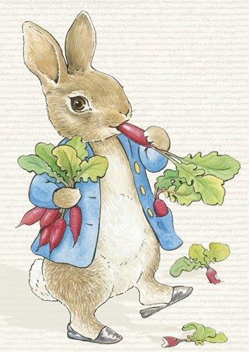  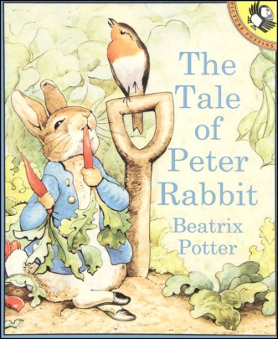  Program the Blue-bot to move from The Tale of Peter Rabbit to Peter Rabbit |  | English Texts Activity Card  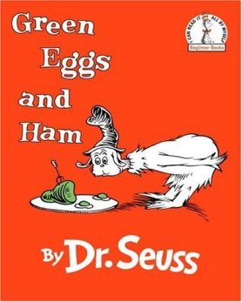  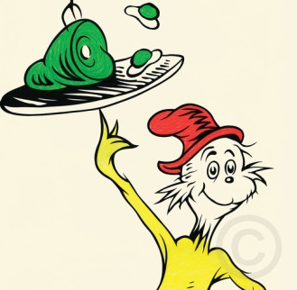  Program the Blue-bot to move from Sam I Am to Green Eggs and Ham
 | English Texts Activity Card  Program the Blue-bot to move from Hagrid to Harry Potter and the Philosopher’s Stone  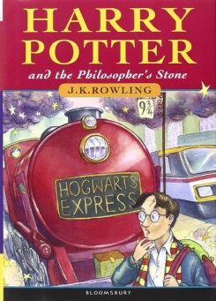  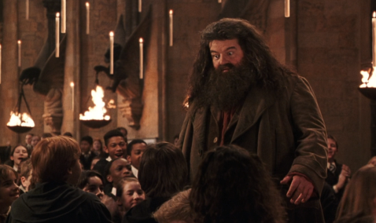 |  | English Texts Activity Card  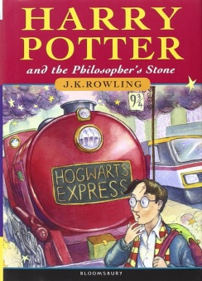  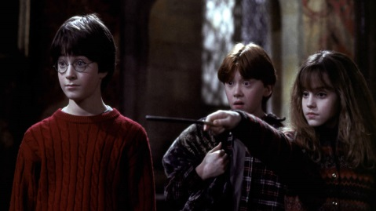  Program the Blue-bot to move from Harry Potter and the Philosopher’s Stone to Harry, Ron and Hermione
English - Texts |  | English - Texts
English - Texts |  | English - Texts

English Texts Activity Card  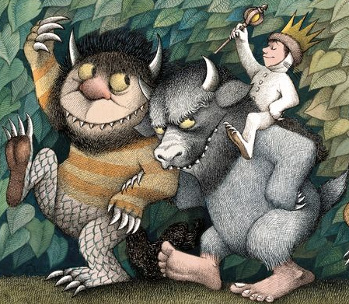  Program the Blue-bot to move from Where The Wild Things Are to Carol, Bull and Max  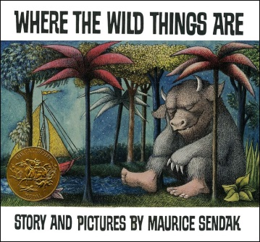 | English Texts Activity Card  Program the Blue-bot to move from Koala Lou and her Mum to Koala Lou  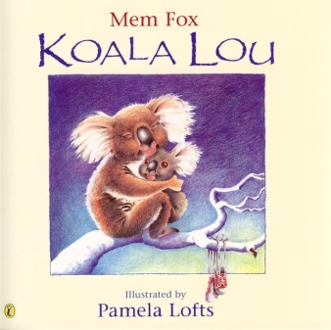
English Texts Activity Card  Program the Blue-bot to move from Grandma Poss to Possum Magic  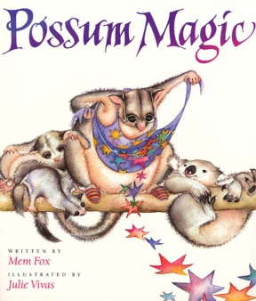  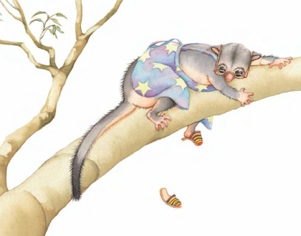 | English Texts Activity Card  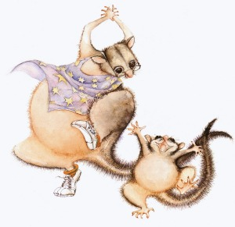  Program the Blue-bot to move from Possum Magic to Grandma Poss and Hush

English - Texts | English - Texts
English - Texts | English - Texts

 | English Texts Activity Card  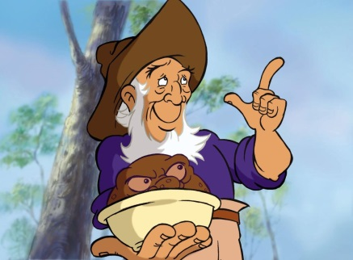  Program the Blue-bot to move from The Magic Pudding to Bill Barnacle and Albert  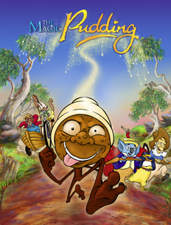 |  | English Texts Activity Card  Program the Blue-bot to move from Bill Barnacle, Sam Sawnoff, Albert and Bunyip Bluegum to The Magic Pudding  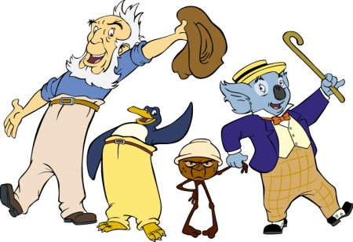
 | English Texts Activity Card  Program the Blue-bot to move from Matilda and her books to Matilda  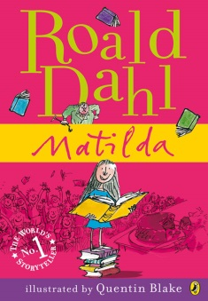 |  | English Texts Activity Card  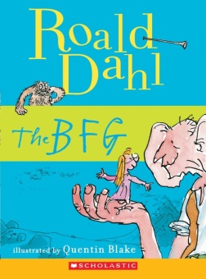  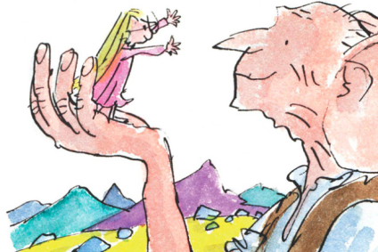  Program the Blue-bot to move from Sophie and the BFG to the BFG
English - Texts |  | English - Texts
English - Texts |  | English - Texts

English Texts Activity Card  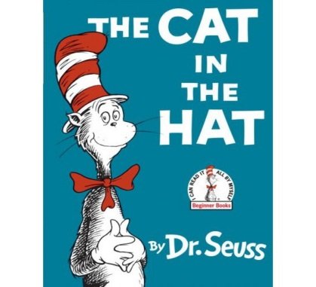  Program the Blue-bot to move from The Cat in the Hat to Thing One and Thing Two  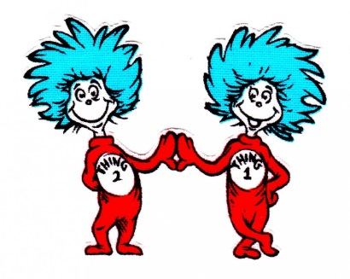 | English Texts Activity Card  Program the Blue-bot to move from The Cat in the Hat to the Cat in the Hat  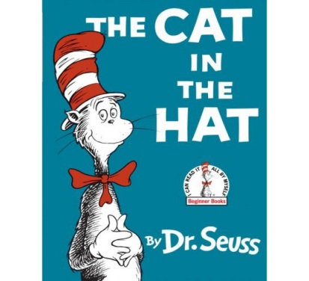  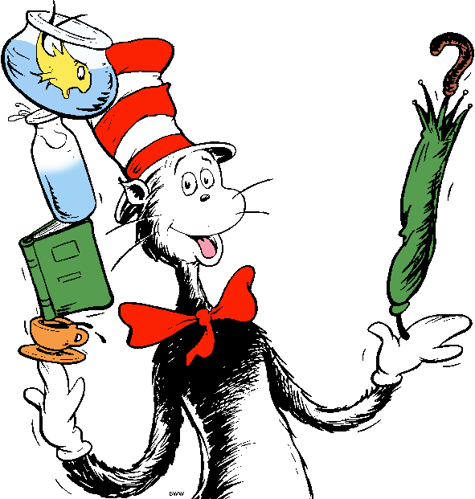
English Texts Activity Card  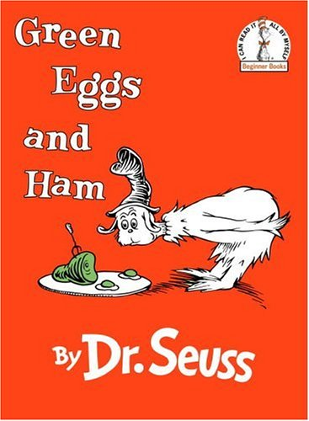  Program the Blue-bot to move from The Cat in the Hat to Green Eggs and Ham | English Texts Activity Card  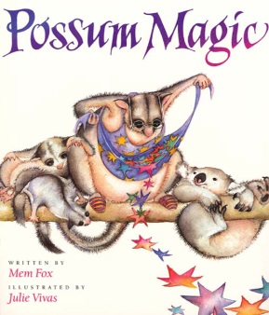  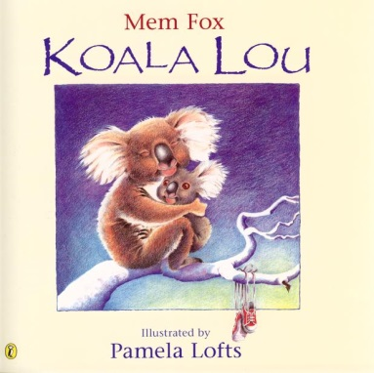  Program the Blue-bot to move from Koala Lou to Possum Magic

English - Texts | English - Texts
English - Texts | English - Texts

English Texts Activity Card  Program the Blue-bot to move from | English Texts Activity Card  Program the Blue-bot to move from
English Texts Activity Card  Program the Blue-bot to move from | English Texts Activity Card  Program the Blue-bot to move from

