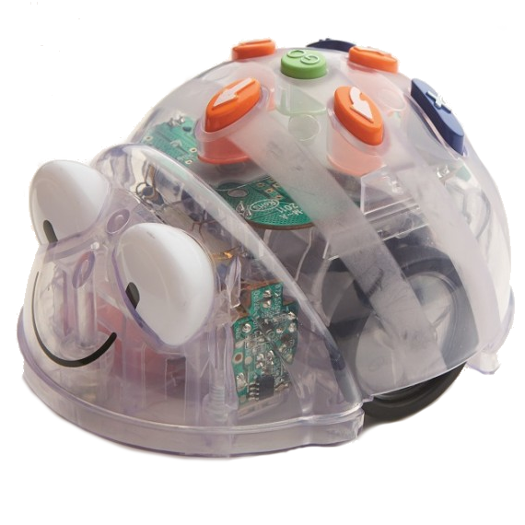  Farm Yard | Farm Yard
Farm Yard | Farm Yard

Blue-bot  Farm Yard Activity Card  Program the Blue-bot to move:  From home to the cow paddock  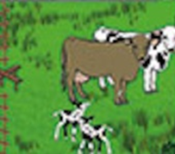  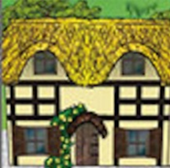 | Blue-bot  Farm Yard Activity Card  Program the Blue-bot to move:  From the chook yard to the scarecrow  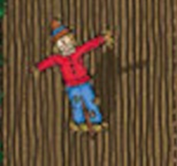  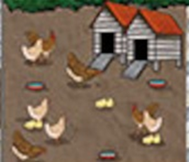
Blue-bot  Farm Yard Activity Card  Program the Blue-bot to move:  From the horse stable to the playground  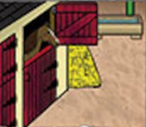 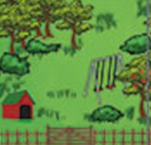 | Blue-bot  Farm Yard Activity Card  Program the Blue-bot to move:  From the piggery to the house  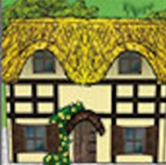  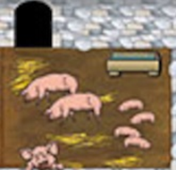

Blue-bot  Farm Yard Activity Card  Program the Blue-bot to move:  From the paddock of sheep to the playground  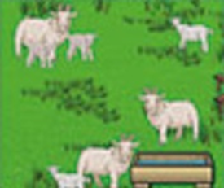 | Blue-bot  Farm Yard Activity Card  Program the Blue-bot to move:  From the piggery to the scarecrow
Blue-bot  Farm Yard Activity Card  Program the Blue-bot to move:  From the house to the horse stable | Blue-bot  Farm Yard Activity Card  Program the Blue-bot to move:  From the field to the tractor in the shed  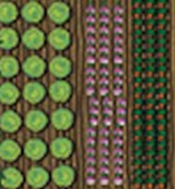  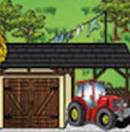

Blue-bot  Farm Yard Activity Card  Program the Blue-bot to move:  From the field to the orchard  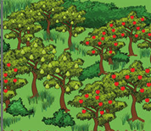 | Blue-bot  Farm Yard Activity Card  Program the Blue-bot to move:  From the paddock of cows to the chicken yard
Blue-bot  Farm Yard Activity Card  Program the Blue-bot to move:  From the black & white sheep to the house  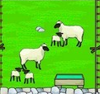 | Blue-bot  Farm Yard Activity Card  Program the Blue-bot to move:  From the playground to the scarecrow

