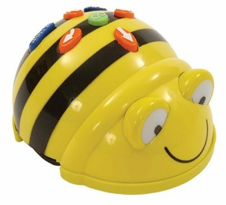  Pictures | Pictures
Pictures | Pictures

Bee-bot Picture Activity Card  Program the Bee-bot to move from the blue castle to the yellow school bag  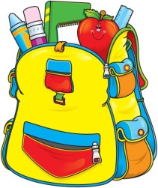  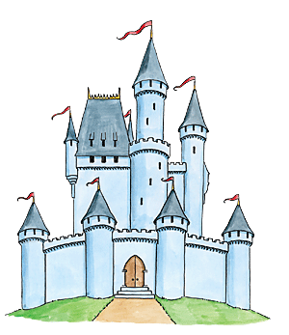 | Bee-bot Picture Activity Card  Program the Bee-bot to move from the orange basket ball to the green and red tomato plant  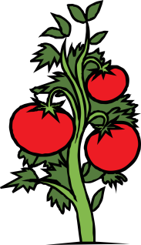  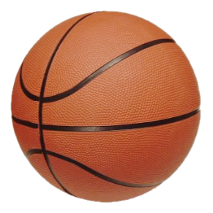
Bee-bot Picture Activity Card  Program the Bee-bot to move from the brown rabbit to the yellow house  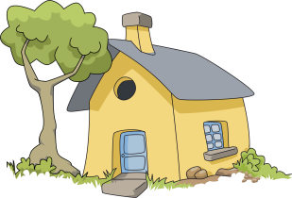  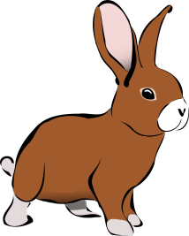 | Bee-bot Picture Activity Card  Program the Bee-bot to move from the orange sun to the blue dolphins

Bee-bot Picture Activity Card  Program the Bee-bot to move from the brown horse to the blue fish in the bowl  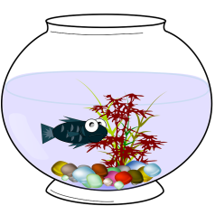  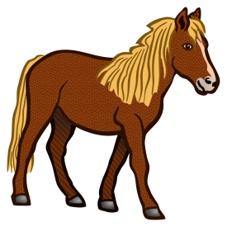 | Bee-bot Picture Activity Card  Program the Bee-bot to move from the brown and green tree to the colourful rainbow
Bee-bot Picture Activity Card  Program the Bee-bot to move from the blue flowers to the red gas tank  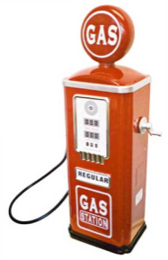 | Bee-bot Picture Activity Card  Program the Bee-bot to move from the girl in bed to the plane  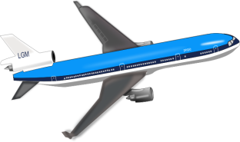  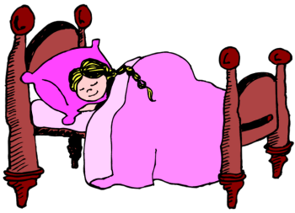

Bee-bot Picture Activity Card  Program the Bee-bot to move from the black bat to the man  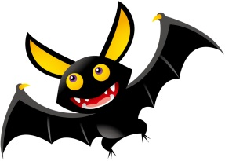 | Bee-bot Picture Activity Card  Program the Bee-bot to move from the baseball bat to the blue cat  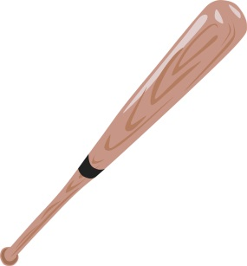
Bee-bot Picture Activity Card  Program the Bee-bot to move from the red barn to the blue castle | Bee-bot Picture Activity Card  Program the Bee-bot to move from the pink pig to the white and black cow  