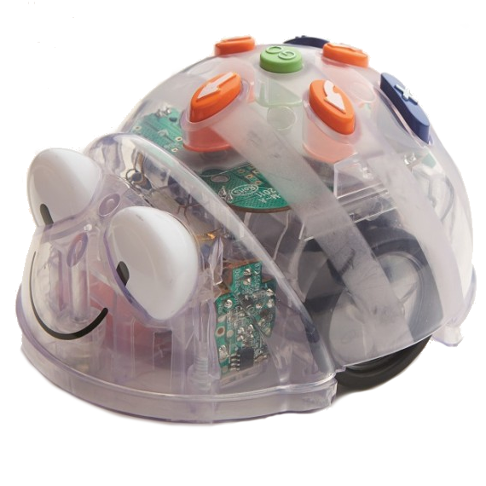  Treasure Island | Treasure Island
Treasure Island | Treasure Island

Blue-bot  Treasure Island Activity Card  Program the Blue-bot to move:  From the pirate ship to the volcano:  going up a ladder  and over the bridge | Blue-bot  Treasure Island Activity Card  Program the Blue-bot to move:  From the swamp to the dungeon:  Going over the river at the rope  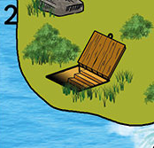  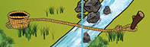
Blue-bot  Treasure Island Activity Card  Program the Blue-bot to move:  From the waterfall to the pirate ship:  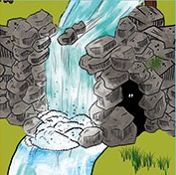 | Blue-bot  Treasure Island Activity Card  Program the Blue-bot to move:  From the sharks to the octopus via the pirate ship  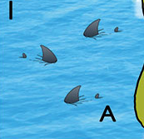 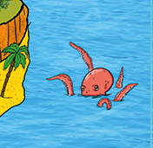

Blue-bot  Treasure Island Activity Card  Program the Blue-bot to move:  From the boat in the sand to the footprint cave:  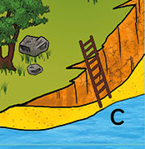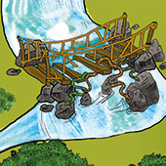Going over the bridge and down the ladder  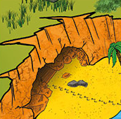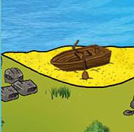 | Blue-bot  Treasure Island Activity Card  Program the Blue-bot to move:  From the octopus to the dungeon:  Going up the ladder and over the bridge
Blue-bot  Treasure Island Activity Card  Program the Blue-bot to move:  From pirate ship to the waterfall:  Going up the ladder | Blue-bot  Treasure Island Activity Card  Program the Blue-bot to move:  From the jungle to the swamp:  Going over the river at the rope  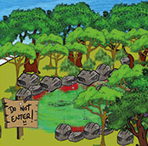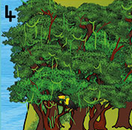

Blue-bot  Treasure Island Activity Card  Program the Blue-bot to move:  From the volcano to the water fall:  Going through the jungle | Blue-bot  Treasure Island Activity Card  Program the Blue-bot to move:  From the dungeon to the big tree:  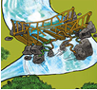  Going over the bridge  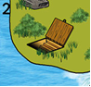  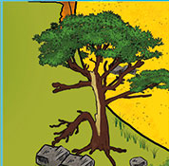
Blue-bot  Treasure Island Activity Card  Program the Blue-bot to move:  From the snapped tree to the beach:  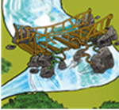  Going down the ladder | Blue-bot  Treasure Island Activity Card  Program the Blue-bot to move:  From Beach to the pirate ship:  Going up the ladder and down the ladder  